6-12-8 Control Law Comparison

Control-law comparison on the 6-12-8 system
Twelve runs · linear plant · 14 September 2026 · rattlesnake-vibration-controller, branch control-law-development-2026-09
Six control laws, each run with the drive-coherence cap on and off, on one plant with every other setting held fixed and machine-verified. Two findings changed the picture since the eight-run revision: the coherence cap means opposite things to feedback and open-loop laws, and a law with no error feedback at all finishes within 0.7 dB of the best feedback law.
What changed since 12 September Runs 09–12 are new: pseudoinverse_control and buzz_control, the two original upstream laws, each capped and uncapped. Every number in this report was recomputed from the run files with one method, so the eight earlier rows may differ in the last digit from the previous revision. The achievable-floor column is unchanged in meaning and reproduces the earlier values (run01 3.88 here, 3.87 there — the difference is floor decimation 5 versus 4).
Correction to the first draft of this report An earlier version of this document claimed that roughly 1.6 dB of the reachability floor was an artefact of the rcond = 1e-3 truncation, and listed relaxing rcond as the cheapest available improvement. That was wrong. The unrestricted floor it rested on (1.96–2.37 dB) was the optimizer exploiting a sixth singular direction that exists only as identification noise. Section 1 has the evidence. There is no headroom there, and the recommendation has been withdrawn.

1. The system under test
Six drives, twelve responses, eight control channels, controlled over 100–1000 Hz against a flat 1×10⁻³ specification with zero cross-terms. The plant is the linear SDynPy frame model sdynpy_frame6x12_system.npz (hardware type 6, 36 DOF), run as virtual hardware at 4096 Hz.
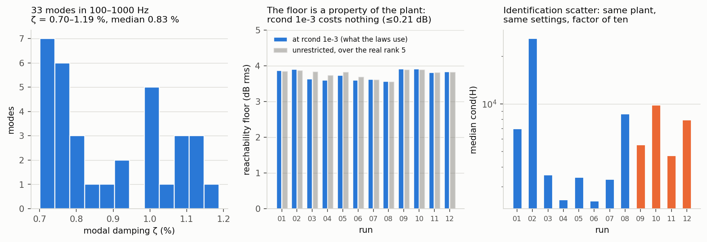
Left: modal damping for the 33 modes inside the control band — lightly damped, median 0.83 %, minimum 0.70 %. Centre: the reachability floor per run, at the rcond the laws actually use and unrestricted over the plant’s real rank-5 subspace; the two agree to 0.21 dB, which is why rcond = 1e-3 costs nothing. Right: median cond(H) per run — the same deterministic plant, identified with identical settings, scattering by a factor of ten.
The reachability limit is structural, not a control failure. With M = 8 control channels and N = 6 drives, the set of achievable response diagonals D = { diag(H X H^{H}) : X ⪰ 0 } is a proper subset of the nonnegative orthant. Part of the flat specification is unreachable by any law. Measured on this plant, per run, from that run's own FRF: 3.57–3.92 dB rms at rcond = 1e-3.

The plant is rank 5, not 6
Computing H analytically from the model's mass, stiffness and damping matrices — validated against the measured FRF, whose magnitude it matches to a median of 0.21 dB and whose first five singular values it reproduces to a few percent — the sixth singular value is ~1×10⁻¹⁷. The six shakers span only a five-dimensional response subspace at these eight control locations. The sixth drive direction buys nothing.
In the measured FRF that direction comes back at 3.9e-05–4.1e-04 of the first singular value, and the numeric rank over the control band is 5 in all twelve runs. That residue is identification noise in a direction the hardware cannot reach.
Consequence: rcond = 1e-3 is correct, and costs nothing Recomputing each floor with no rcond restriction but over the plant's real rank-5 subspace gives 3.56–3.90 dB, within 0.21 dB of the operational floor at every run. The same computation on the raw measured FRF returns ~2.3 dB — but that number is the optimizer spending drive on the noise direction, and it is not achievable. Lowering rcond would invert noise, not recover headroom.

2. What was run
Every run used the same plant, sample rate, averaging, and system-ID configuration. Twenty-three settings are compared across runs by score_runs_sdynpy.py's MUST_MATCH list and a mismatch raises a NOT-COMPARABLE warning rather than being scored silently — a response to an earlier campaign where sixteen runs turned out to span three different plants.
samples per frame 4096 control averaging Exponential, 0.04
sample rate 4096 Hz frames in CPSD 20
time per read/write 0.25 s update sys ID Y (on)
sys ID averages 20 sys ID level 1.0 V rms
control band 100-1000 Hz rcond 1e-3

3. Results
Run | Law | Loop | Cap | rms dB | % out | vs floor | floor | drive V² | level dB | cond(H) | min MC
run01 | match_trace_pseudoinverse | feedback | 0.95 | 8.22 | 27.5 | 7.16 | 3.88 | 0.12 | +0.09 | 6,976 | 0.838
run02 | match_trace_pseudoinverse | feedback | off | 7.21 | 21.1 | 5.78 | 3.90 | 6.019 | +0.05 | 25,928 | 0.275
run03 | optimal_diagonal_control | feedback | 0.95 | 5.62 | 11.2 | 3.99 | 3.64 | 0.07469 | +0.08 | 3,567 | 0.836
run04 | optimal_diagonal_control | feedback | off | 5.62 | 11.2 | 3.99 | 3.61 | 0.07896 | +0.41 | 2,493 | 0.843
run05 | optimal_diagonal_control_fast | feedback | 0.95 | 5.64 | 10.9 | 3.99 | 3.75 | 0.07599 | +0.26 | 3,457 | 0.855
run06 | optimal_diagonal_control_fast | feedback | off | 5.66 | 10.7 | 3.99 | 3.61 | 0.07559 | +0.06 | 2,447 | 0.751
run07 | match_diagonal_congruence | feedback | 0.95 | 5.31 | 19.8 | 3.51 | 3.63 | 0.04694 | +2.85 | 3,354 | 0.882
run08 | match_diagonal_congruence | feedback | off | 5.23 | 18.7 | 3.48 | 3.57 | 0.2107 | +2.78 | 8,676 | 0.841
run09 | pseudoinverse_control | open | 0.95 | 10.47 | 42.1 | 9.55 | 3.92 | 5.449 | +13.55 | 5,543 | 0.546
run10 | pseudoinverse_control | open | off | 7.01 | 17.8 | 5.48 | 3.92 | 5.377 | -1.28 | 9,850 | 0.525
run11 | buzz_control | open | 0.95 | 7.90 | 30.2 | 6.75 | 3.82 | 0.981 | +9.38 | 4,731 | 0.789
run12 | buzz_control | open | off | 5.91 | 13.6 | 4.20 | 3.85 | 1.473 | -0.30 | 7,958 | 0.836
rms dB and % out score the run against the flat specification. vs floor scores it against what this plant could actually deliver, and is the figure that isolates the law's own contribution. floor is how far that best-achievable response itself sits from the specification. min MC is the minimum multiple coherence of the in-control FRF re-identification — a measure of how trustworthy that run's own plant model was.

4. The coherence cap inverts by family
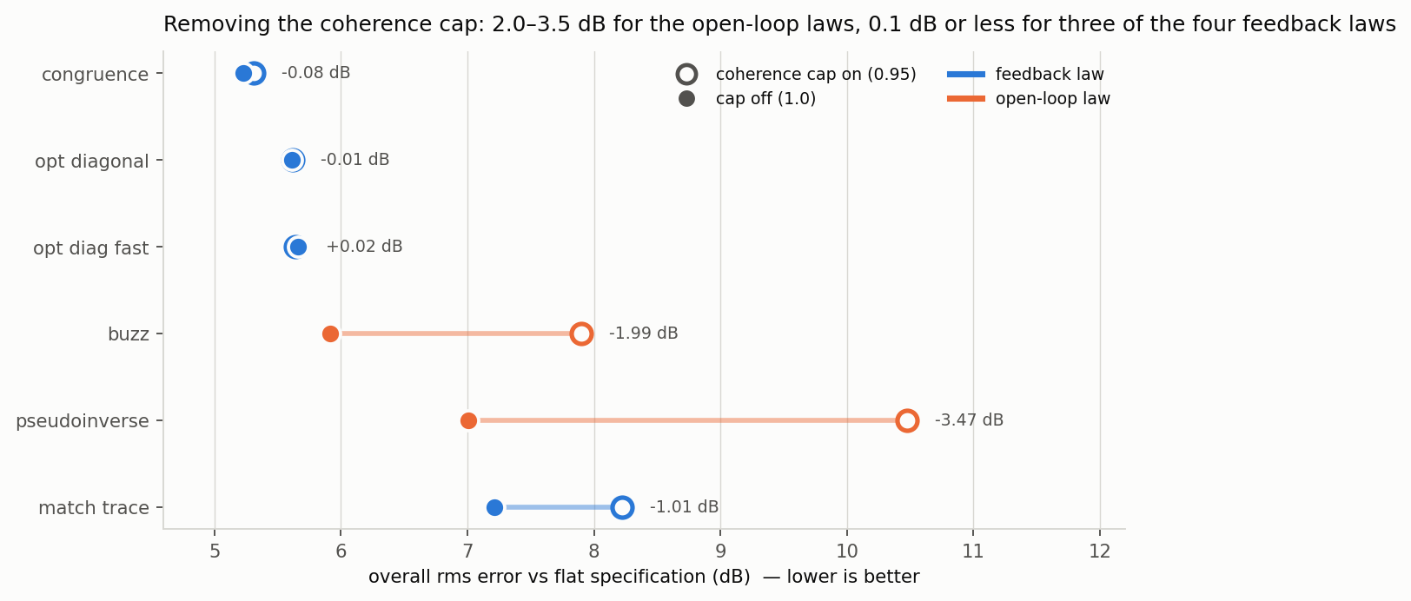
Each law at cap 0.95 (hollow) and cap off (solid). Colour is loop type. The open-loop laws gain 2.0 and 3.5 dB from removing the cap; three of the four feedback laws move by 0.08 dB or less.
Law | Loop | rms cap on | rms cap off | Δ | level on | level off | drive on | drive off
match_diagonal_congruence | feedback | 5.31 | 5.23 | -0.08 | +2.85 | +2.78 | 0.0469 | 0.211
optimal_diagonal_control | feedback | 5.62 | 5.62 | -0.01 | +0.08 | +0.41 | 0.0747 | 0.079
optimal_diagonal_control_fast | feedback | 5.64 | 5.66 | +0.02 | +0.26 | +0.06 | 0.076 | 0.0756
match_trace_pseudoinverse | feedback | 8.22 | 7.21 | -1.01 | +0.09 | +0.05 | 0.12 | 6.02
buzz_control | open | 7.90 | 5.91 | -1.99 | +9.38 | -0.30 | 0.981 | 1.47
pseudoinverse_control | open | 10.47 | 7.01 | -3.47 | +13.55 | -1.28 | 5.45 | 5.38
The mechanism is visible in the drive solution. Both open-loop laws produce a strongly rank-concentrated drive — eigenvalue participation ratio 1.0–1.1 out of 6 — so the six shakers act as essentially one source and the responses cancel by precise inter-drive phasing. _cap_drive_coherence shrinks the off-diagonal terms while preserving the diagonal, which breaks that cancellation: the drive power is barely changed, but the responses now add incoherently and the level jumps. Run 09 sat +13.55 dB above specification and run 11 +9.38 dB; uncapped, the same laws land at −1.28 and −0.30 dB.
A feedback law survives the same treatment because its loop re-converges around the cap as a constraint. An open-loop law has nothing to re-converge with, so the cap is pure damage. The residual is shape error, not level error: the best possible single rescale of run 09's whole drive improves it from 10.47 to only 10.17 dB.
Operational consequence For pseudoinverse_control and buzz_control, cap off (1.0) is the correct setting, not the reckless one. This is the reverse of the feedback-law intuition, and nothing in the parameter name or the docstring warns of it.

5. Feedback buys less than expected
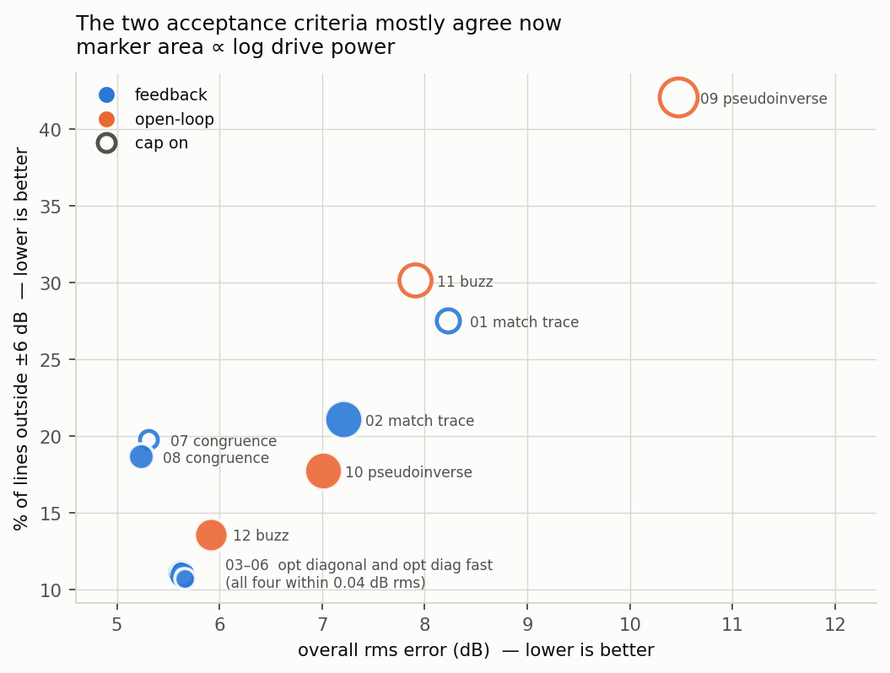
The two acceptance criteria against each other, marker area proportional to log drive power. Hollow markers are cap-on runs. At their correct cap setting the open-loop laws sit inside the feedback cluster.
buzz_control at 5.91 dB / 13.6 % finishes 0.68 dB behind the best run in the matrix and ahead of both match_trace_pseudoinverse runs — with no error feedback whatsoever. Tracing the code confirms it: last_response_cpsd appears in the signature and the docstring and never in the body; last_output_cpsd is read only as a first-call sentinel for the startup clamp. The law recomputes the same open-loop solve every cycle.
Its one adaptive channel is the plant model. With update_tf_during_control = Y the FRF is re-identified from live control data, but sysid_response_cpsd — the source of the coherence and phase it matches — is assigned only during system ID and is frozen for the whole run. So the law adapts to a changing plant, not to its own error, which is why runs 11 and 12 sat at a steady offset instead of converging toward 0 dB.
The reading this supports: on this plant the 5.2–5.9 dB cluster is set by reachability and identification quality, not by loop design. What separates the laws is how sensibly they choose a target inside the reachable set. buzz_control's substitution of measured coherence and phase for the specification's unreachable diagonal is worth 1.1 dB and a third of the drive against pseudoinverse_control, which inverts the raw diagonal target and pays for it.

6. Separating the law's error from the plant's limit
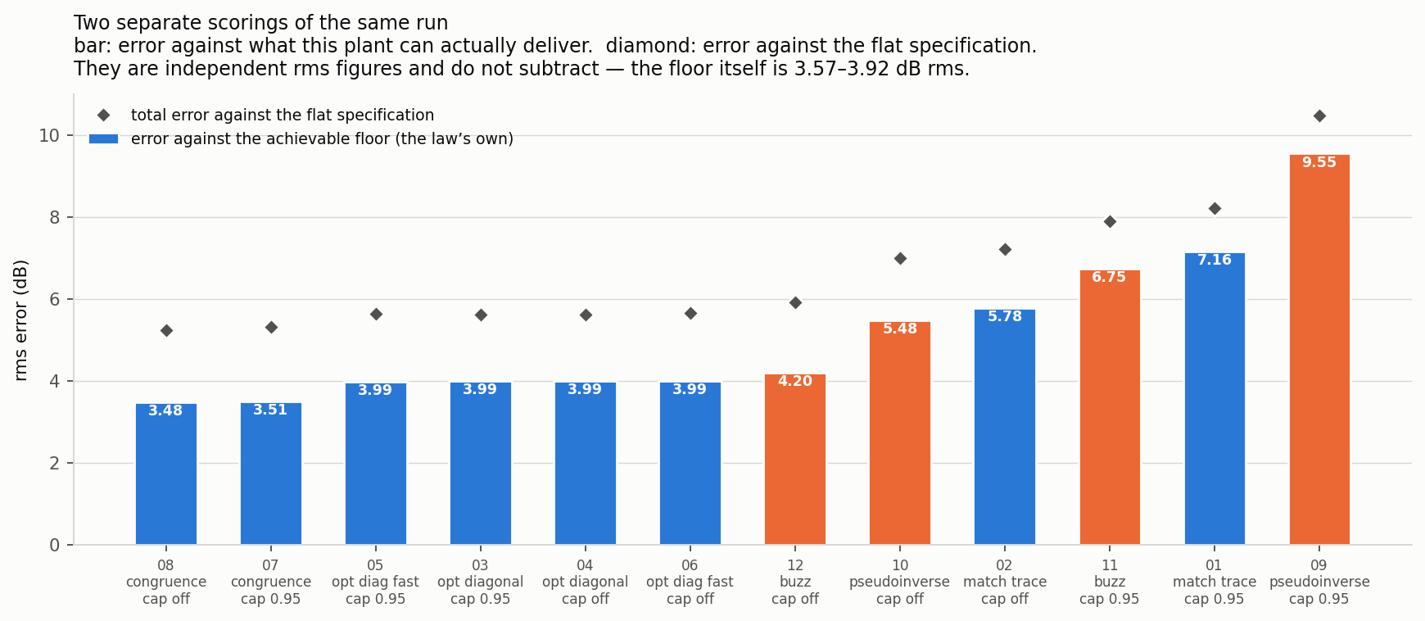
Two independent scorings of each run. The bar is error against the achievable floor - the law's own contribution. The diamond is total error against the flat specification. These are separate rms figures and do not subtract.
Ranked against the floor, match_diagonal_congruence leads at 3.48–3.51 dB, the optimal-diagonal family follows at a flat 3.99 dB, buzz_control at 4.20, then pseudoinverse_control at 5.48 and match_trace_pseudoinverse at 5.78. The ordering is not the same as the flat-spec ordering — congruence sits +2.8 dB high in level, which costs it against the specification but not against the floor.

7. The same two channels dominate every law
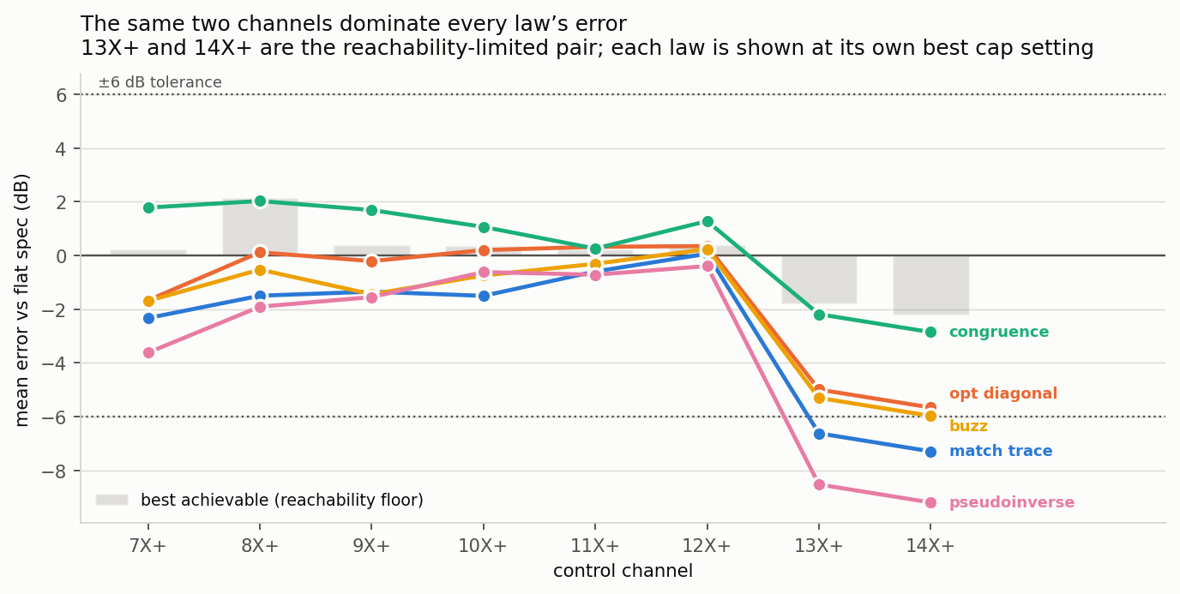
Mean per-channel error, each law at its own best cap setting, with the reachability floor behind. Channels 13X+ and 14X+ are the reachability-limited pair.
Six of the eight control channels sit within a couple of dB under every law. 13X+ and 14X+ are the two directions six shakers cannot independently command, and every law undershoots them: −2.2/−2.8 dB for congruence, −5.3/−6.0 for buzz, −6.7/−7.3 for match_trace, −8.5/−9.2 for pseudoinverse. The laws differ mainly in how much drive they are willing to waste trying.

8. Cross-terms: the specification asked for zero
The flat specification is diagonal — every off-diagonal term is zero. None of these six laws controls the off-diagonals; every one of them matches the diagonal and lets the cross-structure fall out. It does not fall out small.
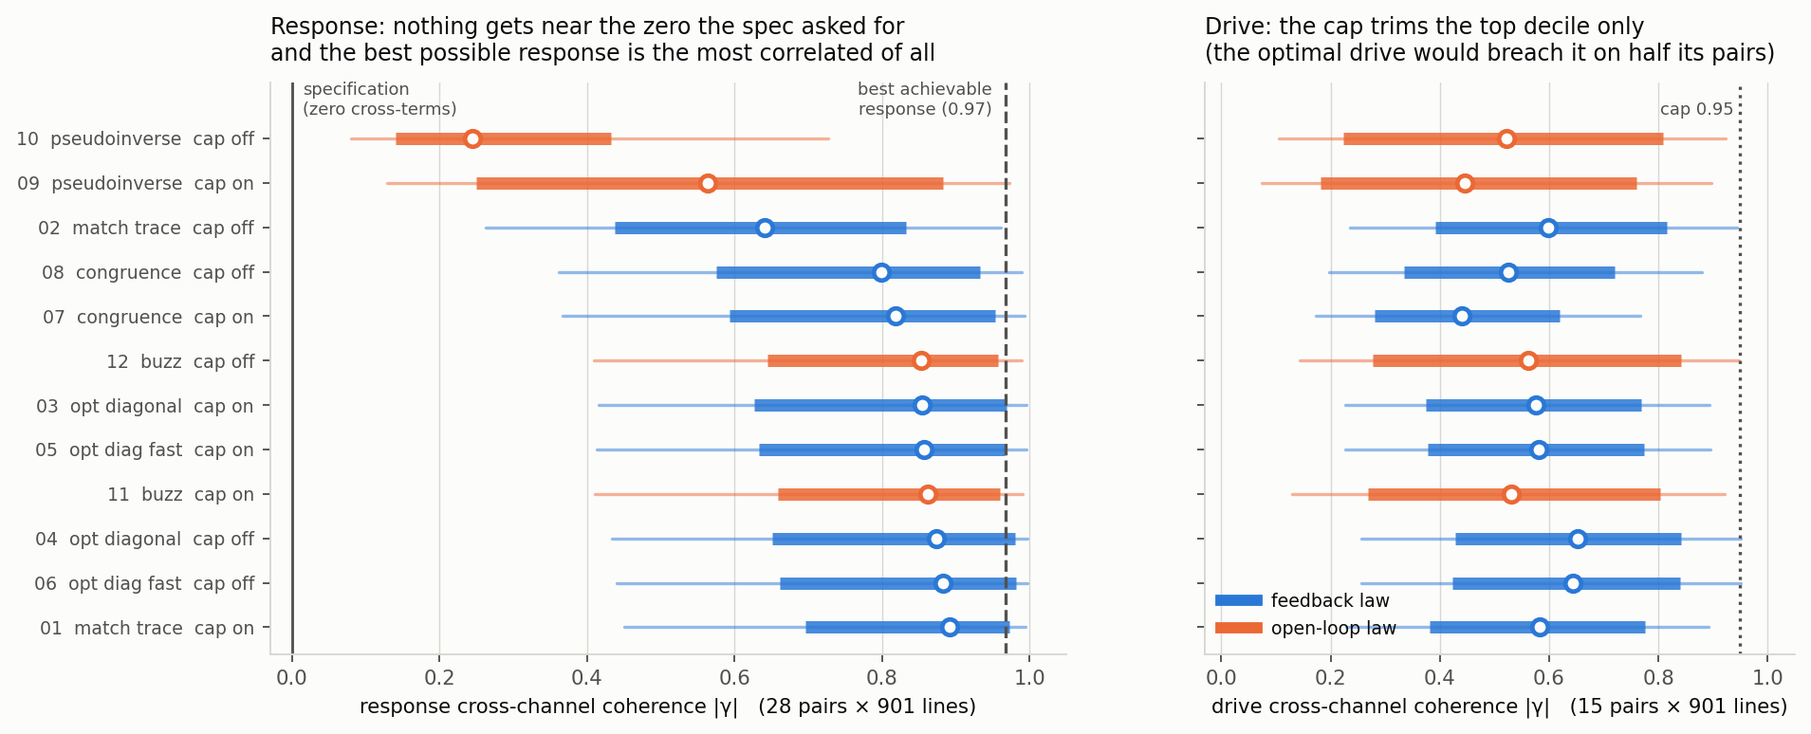
Cross-channel coherence magnitude across all twelve runs. Box is the quartile range, whisker the 10th-90th percentile, marker the median. Left: response, 28 channel pairs over 901 in-band lines. Right: drive, 15 pairs.
Run | Law | Loop | Cap | resp median |γ| | resp p90 | eig participation | drive median |γ| | drive % > 0.95
run10 | pseudoinverse_control | open | off | 0.245 | 0.727 | 4.46 | 0.522 | 6.4
run09 | pseudoinverse_control | open | on | 0.564 | 0.973 | 2.15 | 0.446 | 2.2
run02 | match_trace_pseudoinverse | feedback | off | 0.640 | 0.961 | 1.77 | 0.599 | 9.2
run08 | match_diagonal_congruence | feedback | off | 0.799 | 0.990 | 1.43 | 0.525 | 5.0
run07 | match_diagonal_congruence | feedback | on | 0.818 | 0.994 | 1.39 | 0.440 | 0.1
run12 | buzz_control | open | off | 0.853 | 0.989 | 1.41 | 0.562 | 9.5
run03 | optimal_diagonal_control | feedback | on | 0.855 | 0.996 | 1.47 | 0.576 | 1.7
run05 | optimal_diagonal_control_fast | feedback | on | 0.857 | 0.996 | 1.49 | 0.581 | 1.9
run11 | buzz_control | open | on | 0.862 | 0.991 | 1.30 | 0.531 | 3.1
run04 | optimal_diagonal_control | feedback | off | 0.873 | 0.998 | 1.42 | 0.652 | 10.2
run06 | optimal_diagonal_control_fast | feedback | off | 0.883 | 0.998 | 1.45 | 0.644 | 10.1
run01 | match_trace_pseudoinverse | feedback | on | 0.892 | 0.995 | 1.15 | 0.583 | 1.3
Median response coherence runs from 0.245 to 0.892, with the 90th percentile above 0.96 for nine of the twelve runs. In absolute terms the off-diagonal magnitudes sit within a few dB of the 1×10⁻³ diagonal — the same order as the specification itself, not a small perturbation on it.

Zero cross-terms is unreachable, not merely difficult
The plant is rank 5 (section 1), so the response CPSD H X H^{H} has rank at most 5 in an eight-dimensional space. A genuinely diagonal 8×8 CPSD has rank 8. The specification therefore asks for something outside the achievable set for a second, independent reason beyond the magnitude shortfall on 13X+ and 14X+.
The eigenvalue participation ratios put a number on how far outside. Nine of the twelve runs sit between 1.15 and 1.5 effective response directions out of eight — all eight control channels riding essentially one motion pattern.
The optimum is the most correlated response of all Solving for the drive that best matches the flat diagonal magnitudes and then measuring its cross-terms gives a median coherence of 0.967 and a participation ratio of 1.19. The best achievable response is more correlated than almost every law delivered. Chasing decorrelation moves away from matching the specification, not toward it.
Run 10 is the control experiment in the other direction. It is the only run that produced substantially independent responses — median coherence 0.245, participation 4.46 — and it spent 5.38 V² doing it, roughly seventy times the optimal-diagonal family, to finish at 7.01 dB against their 5.62. Decorrelating the response is expensive and buys nothing here, because nothing in the acceptance criterion looks at it.

What the cap does to the drive
The cap acts on the drive, not the response, and it bites only the upper tail: median drive coherence moves 0.440 to 0.525 for congruence and 0.576 to 0.652 for optimal diagonal, while the fraction of pairs above 0.95 goes from roughly 0–3 % to 5–10 %. For context, the optimal drive found by the floor solver sits above 0.95 on 49 % of its pairs, median 0.944 — the cap constrains the solution away from the optimum by construction, which is section 4's result seen from the drive side.
Reading the cap-on runs Capped runs still show a few percent of measured drive pairs above 0.95. The cap applies to the commanded drive CPSD; what is saved and scored here is the measured one. A small excess is expected and is not evidence the cap failed.
Consequence for real tests. If response cross-terms matter for the article under test — and on a real structure they often do — none of these laws gives control over them, and no parameter setting changes that. It needs a law carrying off-diagonal terms in its objective and a specification that states them. buzz_control is the only law here that references measured coherence at all, and it copies the plant's rather than commanding anything.

9. Drive power
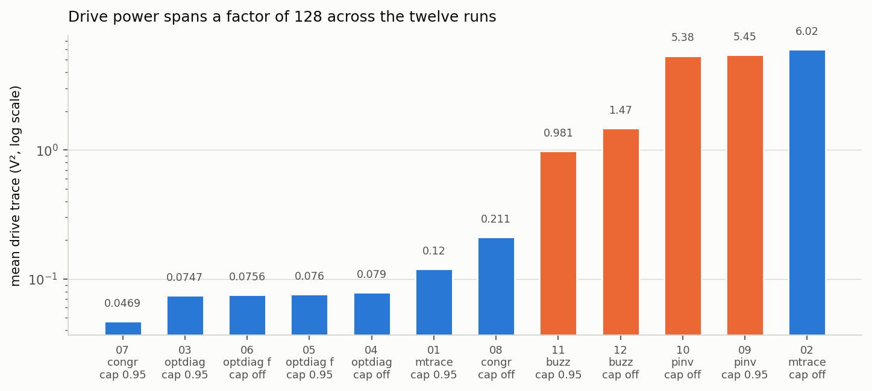
Mean drive trace per run, log scale, coloured by loop type. The spread across twelve runs is a factor of 128.
Drive power spans 0.04694 to 6.019 V², a factor of 128. The open-loop laws are expensive: buzz_control uncapped uses 1.47 V², about twenty times the optimal-diagonal family, for a 0.3 dB worse score. If drive headroom is the binding constraint rather than control accuracy, the ordering changes completely and match_diagonal_congruence with the cap on (0.047 V²) wins outright.

10. Caveats
- Runs 05 and 06 did not test what they were meant to. optimal_diagonal_control_fast disables its Burer-Monteiro fast path whenever the FRF changes between calls, because the unconstrained factored solve drives pairwise drive coherence to exactly 1.0 and would make a live H1 estimator's reference CPSD singular. With update_tf_during_control = 1, H changes every call, so every solve fell back to the base class's SDP. Runs 05 and 06 are repeats of 03 and 04, and their close agreement is not evidence that the factored solve matches the SDP. No timing difference was observed at the rig, consistent with this.
- The coherence cap in the optimal-diagonal laws reaches only SDP-refined bins, bounded by max_bins_per_update = 20 per call. Across 901 lines most bins carry the deliberately uncapped buzz baseline in both runs, which likely explains the null result there. Raising the bin budget would distinguish "the cap does not matter to this law" from "the cap barely applied".
- pseudoinverse_control has no startup guard. It is the only law in the set without the first-cycle clamp added 2026-09-02. On frame one the FRF is a single unaveraged estimate and the commanded level can be decades high. Runs 09 and 10 completed without tripping, but this is luck of the identification, not safety.
- buzz_control_generator and buzz_control_class have neither the cap nor the startup guard, and buzz_control_class.control() accepts last_response_cpsd and never references it — it replays one open-loop solve forever. Both were excluded from this comparison deliberately.
- Run 10 has the second-worst in-control FRF in the matrix (minimum multiple coherence 0.525, behind only run 02's 0.275). Both are the uncapped, near-coherent-drive cases, where the H1 re-identification is fed a drive with little independent content. Run 10's 7.01 dB rests on the least trustworthy plant model here.
- Every floor in this report is a rank-5 floor. The computation restricts the drive either by rcond or by explicit truncation; both land in the same place because the plant really is rank 5. Any floor computed on a raw measured FRF without one of those restrictions will come back optimistically low by about 1.6 dB, for the reason given in section 1. This bit the first draft of this report.
- Identification scatter is large. Median cond(H) came out 2,447–25,928 across twelve identifications of the same deterministic plant with identical settings — a factor of ten. Differences between laws smaller than a few tenths of a dB should not be read as real. This is why the achievable floor is recomputed per run rather than assumed common.
- Run 01 may have been saved short of convergence. Its optimal single rescale is +3.37 dB, which would improve it from 8.22 to 7.50 dB rms — the only run in the matrix with a large one-sided level offset under a law that integrates. It does not change any ordering, but the match_trace cap-on row is the weakest number here.
- Neither optimal-diagonal law has a startup level cap. match_trace, buzz and congruence all take startup_test_level_cap_db (−9 dB default); the optimal-diagonal laws solve against the full specification and command it immediately. Worked around by ramping the test level. Still unfixed.
- bm_rank was set to 6, not its default of 4. With eight control channels the threshold below which spurious local minima generically appear is √(2·8) ≈ 4, so the default sits exactly on it. Moot given the fast path never engaged.
- The profiles carry no warning or abort levels — those columns are all NaN — so the ±6 dB tolerance bands are synthesized from the specification. Putting real tolerances in the profile would make these numbers contractual rather than nominal.
- One test level, one averaging configuration, one plant, no repeats. No per-law variance estimate exists. The plant is lightly damped (median ζ 0.83 %), which is the harder case; a better-damped structure would likely narrow the spread between laws.
- An offline predictor was used during the campaign and was systematically wrong in magnitude. Reconstructing each law's solve from a frozen FRF predicted 15.73 dB for run 09 (actual 10.47), 12.28 for run 11 (actual 7.90) and 3.87 for run 12 (actual 5.91). It called every ordering correctly and no magnitude within 2 dB. The frozen-FRF assumption is the reason: the live laws re-invert an updating estimate.
- Floor method. achievable_diagonal on each run's own control FRF, every 5th in-band line, log-interpolated, restrict_rcond = 1e-3. Decimation was checked against every-2nd and every-20th line and moves the result by 0.05 dB or less.

11. Next
- Find out why the plant is rank 5. If the sixth shaker is redundant by construction rather than by accident of this model, that matters for the rig and not just the simulation — it would mean one drive channel is doing nothing, and that the 8×6 problem has always been 8×5. The analytic FRF makes this cheap to investigate.
- Higher damping, same geometry. sdynpy_frame6x12_system_higherz.npz has identical mass and stiffness — mode frequencies match the nominal plant to 0.0000 Hz — with ζ raised from a 0.83 % median to 3.34 %. Its floor is 4.05 dB against the nominal 4.09, so damping does not change what is reachable; it halves the conditioning over the real directions (68 to 33). That isolates the identification-quality hypothesis this report's caveats raise.
- buzz_control with the FRF update off. That makes the law fully static after cycle one, so the difference against run 12 measures exactly what plant-model adaptation is worth with nothing else varying. One run.
- Raise max_bins_per_update and repeat runs 03/04, to settle whether the optimal-diagonal cap null result is real.
- Rerun the fast law with the FRF update off, so the Burer-Monteiro path actually engages and runs 05/06 test what they claim to.
- Phase two — the achievable target as specification. make_achievable_spec.py is built and verified but still unused. Pointing every law at a reachable target removes reachability from the comparison so the residual is tracking behaviour alone.
- Add a startup level cap to both optimal-diagonal laws, and to pseudoinverse_control. Open defect.
- Decide whether response cross-terms are in scope at all. Section 8 shows they are large, uncontrolled, and structurally impossible to zero on this plant. If they matter for a real article the campaign needs a law with off-diagonal terms in its objective and a specification that states them; if they do not, that should be written down so the diagonal-only comparison is understood as deliberate rather than accidental.
Generated from report_data.json by build_report.py; figures by make_report_figures.py; per-run floors by compute_report_data.py. All three in examples/sixdrive12resp/code/.

